Business Process: Standard Billing
Contact
Business Process Owner | Billing Operations
Subject Matter Expert(s) | Ginny Briody, Joshua Dunn, Katherine Martinez Wendy Cates
Key Contact | Tina Dorsette
Key Role | Customer Services Assistant  Customer Services Representative II  Customer Services Supervisor  Senior Customer Services Representative  Revenue Analyst
Date Created | 3/27/2026

Business Process Overview
The Standard Billing process defines how SMUD bills and invoices customer accounts, beginning with customer account establishment and continuing through bill presentment. This process depends on the Meter-to-Cash technology stack, which is presently composed of three distinct systems, each with specific roles and responsibilities:
- Head-End System: Utility IQ (UIQ)
  - Responsible for meter data collection
  - Communicate with endpoint devices through the Advanced Metering Infrastructure (AMI) mesh network to retrieve interval and register data
  - Store a limited amount of meter data
- Meter Data Management System: Itron Enterprise Edition (IEE)
  - System of record for meter data
  - Manage the Validation, Editing, and Estimation (VEE) processes to ensure data quality for meter data received from the head-end system
  - Calculate Billing Determinants
- Customer Information System: SAP ERP Central Component (ECC)
  - System of record for customer information
  - Calculate billing documents based on validated meter data
  - Submit invoices to print vendor

SMUD utilizes AMI mesh network to collect meter data that forms the basis for timely and accurate billing. Most of SMUD’s endpoints are Meter Data Unification Synchronization (MDUS) enabled, allowing for billing determinant calculations. The non-standard billing process, which applies to non-MDUS enabled devices, is outside the scope of this Business Process Overview.

Billing Operations owns and manages the Standard Billing process, while Information Technology provides support for the underlying enterprise systems. This overview highlights the meter-to-cash process and common exception handling areas.

Business Process Assumptions, Prerequisites, Dependencies
(Assumptions pertaining to the business process)
People | - Assumptions:  - Have necessary permissions to facilitate Meter to Cash process  - Are adequately resourced to maintain operational tasks  - Prerequisites:  - Are trained to navigate and remediate exceptions within Meter to Cash process.  - Dependencies:  - Billing Operations permission approvals  - Information Technology permission provisioning
Process | - Assumptions:  - Technology stack supports timely and accurate billing  - Prerequisites:  - N/A  - Dependencies:  - Meter Data Collection (UIQ)  - Validation, Editing and Estimations (IEE)  - Calculate Billing Determinants (IEE)  - Billing and Invoicing (SAP ECC)
Technology | - Assumptions:  - Meter to Cash - Technology Stack  - Compliance with SMUD’s rules and regulations  - Backup systems in place in the event of a Disaster Recovery  - Support Advanced Metering Infrastructure (AMI)  - Head-End System  - Support designated meter data interval such as 5-minute intervals  - Support all of end points (Devices, Access Points, Relays, etc.)  - Meter Data Management System  - Conduct Validation, Editing and Estimation (VEE) aligned with established business process  - Support primary task of timely and accurate billing  - Output data for ancillary use cases related to data analytics and customer programs  - Retain meter data aligned with SMUD’s data retention policy  - Customer Information System  - Produce documents necessary for Bill Print Vendor and internal users of data  - Serve as a repository of documents generated  - Bill Print Vendor  - Support and processes Bill Inserts and/or marketing materials as needed  - Print and ensure delivery of invoices timely  - Perquisites:  - N/A  - Dependencies:  - Utility IQ (UIQ) – Head End System  - Itron Enterprise Edition – Meter Data Management System  - SAP ECC – Customer Information System  - Kubra – Bill Print Vendor

Process Flowchart
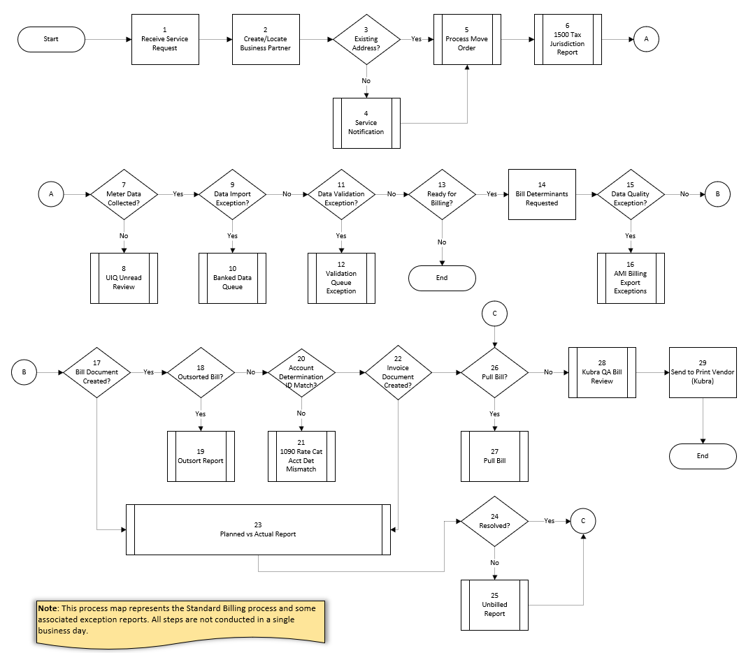

Task Description
Id | Task Description | Procedure
1 | Receive Service Request | Receive request for service via Contact Center, Self-Service Channel or in person at SMUD lobby
2 | Create/Locate Business Partner | Create/Locate existing Business Partner (CRM)
3 | Existing Address? | Check SAP ECC to confirm if Service Address exists
4 | Service Notification | Create Service Notification (SN) for New Service
5 | Process Move Order | Process Move Order for Business Partner (CRM)
6 | 1500 Tax Jurisdiction Report | Reviews Move Orders and audit Tax Jurisdiction Code accuracy
7 | Meter Data Collected? | Collect meter data in Utility IQ (UIQ)
8 | UIQ Unread Review | Investigate/remediate meters not collecting data
9 | Data Import Exception? | Import data from UIQ to Itron Enterprise Edition (IEE), route exceptions to the queue
10 | Banked Data Queue | Resolve Banked Data Queue exceptions
11 | Data Validation Exception? | Validate meter data (IEE) and route exceptions to the queue
12 | Validation Queue Exception | Resolve Data Quality exceptions
13 | Ready for Billing? | Billing occurs typically following Billing Cycles and Bill Order Creation following a 21-cycle schedule
14 | Billing Determinants Requested | Request Bill Determinants for Installations based upon Bill Cycles
15 | Data Quality Exception? | Route Data Quality exceptions to AMI Billing Export (ABE) queue
16 | AMI Billing Export Exceptions | Resolve Data Quality exceptions
17 | Bill Document Created? | Generate Bill Document and Outsorted documents
18 | Outsorted Bill? | Determine if there are Bill Documents outsorted
19 | Outsort Report | Review Outsorted Bill Documents to release or reverse
20 | Account Determination ID Match? | Evaluate Contract, Contract Account for inconsistencies and return results to 1090 Rat Cat Acct Det Mismatch report
21 | 1090 Rat Cat Acct Det Mismatch | Resolve Mismatch Account Determination ID
22 | Invoice Document Created? | Generate Invoice Document
23 | Planned vs Actual Report | Identify Installations scheduled to bill but have not (daily report)
24 | Resolved? | Resolve Installations from Planned vs Actual Report
25 | Unbilled Report | Identify Installations scheduled to bill but have not (weekly report)
26 | Pull Bill? | Is Pull Bill Required?
27 | Pull Bill | Complete Pull Bill Process
28 | Kubra QA Bill Review | Review Invoice images to remediate/identify issues prior to sending file to print vendor (Kubra)
29 | Send to Print Vendor (Kubra) | Submit data to print vendor (Kubra)

Business Rules
Id | Event Name | Business Rules
2 | Create/Locate Business Partner | Business Parter must be authenticated
6 | 1500 Tax Jurisdiction Report | New Move Orders are returned to report following business day
21 | 1090 Rat Cat Det Mismatch | Report Mismatches with Account Determination
23 | Planned vs Actual Report | Report output to network drive daily (\\sapifs\prd\sap_ccs\reports\plannedvsactual)
25 | Unbilled Report | Report output to network drive weekly (\\sapifs\prd\sap_ccs\reports\unbilled_accounts)

Event | Legal Requirements, Rules, and Regulations  Legal documents/ procedures/ requirements to be fulfilled before/at the specified event.
Id | Event | Legal Requirements, Rules and/or Regulations
1 | Receive Service Request | Application for Service Rule and Regulation 3  - Information Required each prospective customer applying for service
2 | Create/Locate Business Partner
7 | Meter Data Collected? | Billing, Payment of Bills, and Credit Rule and Regulation 6  - Billing Period (27 to 34 days)  - Metering for Billing Purposes  - Data from two or more meters will not be combined  - Establishment of Credit  - Late Payment Charge
17 | Bill Document Created
22 | Invoice Document Created?

Pain Points and Improvement Opportunities
- 1001 General Services Report (Report Tree Item)
  - Identifies Rate Changes without attempting to process (if automated rate changes also add a hard stop which can be applied manually based upon SMUD specified criteria such as adding a flag)
  - Unable to drill into Installations for additional details
  - Reliance on CIC0 Rate Change workflow
    - If incorrect Rate is used and it is completed, we cannot go back same day must wait until next business day.
  - Only Rate Change Reversal can be completed via CRM
- 1040 3 Or More Minimum Bills (Report Tree Item)
  - Report lacks logic necessary to make it efficient: once a Business Partner is reviewed and low usage is aligned there is no method to remove them from reporting again
  - Delayed notification of non-relevant meters with zero usage, preference for proactive approach instead of waiting for 3 minimum bills
  - Inability to interact with report and drill into Installations for additional details
- 1090 Rat Cat Acct Det Mismatch Report (Report Tree Item)
  - Reports closed Contract Accounts (causing manual work)
  - Reports mismatches without attempting to fix
  - Reports symptoms instead of identifying resolving root problems to mitigate exceptions
  - Inability to interact with report and drill into Installations for additional details
- 1500 Tax Jurisdiction Report(Report Tree Item)
  - Inability to audit changes completed by a user without reprocessing report and conducting manual comparisons
  - Manual tax assignments required jurisdictions like Galt/Folsom
  - Inability to apply taxes based upon Business Partner which causes repeat work for each new Contract
- AMI Billing Export Exceptions
  - PI/PO replacement
  - Inability to update the ABE Owner queue list (invalid or expired users displayed in causes extra scrolling or inadvertent selections)
  - Reliance on Excel workbook to track exceptions no built in analytic for historical analysis
- Banked Data Queue
  - Banked Data with duplicate data intervals remain in queue for 10 days after team members already reviewed the information (unable to reprocess due to issue to clear the queue)
  - Manual transactions relied upon reverse meter installations, if possible reverse meter install workflow would expedite and standardize processing
  - Report includes false positives whereas items fixed yesterday show up today
  - Reliance on Excel workbook to track exceptions no built in analytic for historical analysis
- Billing
  - EL01 displays Bill Orders which are already associated with Billing Documents
  - EL31 requires multiple mouse clicks to access Billing Determinants for a single location
  - Move Orders are possible for non-metered locations for rates which require meters resulting in poor customer experience and additional manual work
  - Service Notification required for New Address creation
    - Inability to modify Service Notification information for mass workflow transactions creates manual work to update individual customer accounts (such as mailing addresses, or Business Partner selections)
  - Unable to request Bill Determinants for multiple months at once. Must create individual Bill Document before requesting Bill Determinants for the next bill period.
  - Reversing Bill Document also reverses Bill Determinants, would be nice if they could remain if billing corrections are unrelated to interval data
- Kubra QA Bill Review
  - Files must be available by 07:30, and if not must communicate with Customer & Community Services Operation Support (CCSOS) – represents process inefficiency would prefer more proactive engagement or automated notifications where applicable.
  - Must be completed by 09:30 if not files are released for Kubra to print and send to customer
  - Kubra system interface:
    - searching multiple rates, but limited sample size (single account for each rate) efficacy of audits is questionable
    - inability to support QA process without manual work (such as built in bulk-auditing or reporting)
    - times out (forces user sign off) frequently settings cannot be modified by user
- Outsort Report
  - Net Energy Metering solar bills lack unique outsort criteria for settlement bills requiring manual review
  - No historical analytical capabilities to refine Outsorting criteria
  - Available Outsorting check groups are not aligned with customer usage
  - Manually applying Outsorting check groups
- Planned vs Actual Report
  - Retrieving a CSV file, outside of source system
  - Items reported which do not require action such as suppressed bill documents or accounts with alternate portions
  - No KPI measurement available in source system
- Unbilled Report
  - Retrieving a CSV file, outside of source system
  - Items reported which do not require action such as suppressed bill documents or accounts with alternate portions
  - Manually preparing summaries which are not available in source system
  - Manual KPI measurements (how long item is aging)
  - Using Excel formulas to:
    - Retrieve assignments and previous notes
    - Group aging buckets
  - Manually assigning accounts to employees for review
  - Bill Block field shows (what type is displayed) but does not show who placed it causing manual work
  - Inability to identify accounts with invoice locks causing manual work to identify
  - Move in with no device results in (Bill block 13) created
- UIQ Unread Review
  - Manual work with Excel workbooks, copy and paste, exporting from UIQ, reliance on Excel formulas
  - Lack of one-stop shop for conducting research, IW59, DLN, contact logs instead of multiple transaction codes and systems
- Validation Queue
  - Unable to bulk resolve, limit is processing 100 items which causes repeat manual work
  - Changing assignment owner or refresh collapses Validation Rule results, they must be re-expanded to continue working causes repeat manual work and additional mouse-clicks
  - No built-in analytics for historical analysis

Departments impacted by process change

Department | Type of Change(s) | Action Required
Accounting | - 1090 Rate Cat Acct Det Mismatch  - TBD | - Communication  - Documentation Updates  - Training  - TBD
Billing Operations | - Service Notification  - Move Order Process  - 1500 Tax Jurisdiction Report  - UIQ Unread Review  - Banked Data Queue Resolution  - Validation Queue Exceptions  - AMI Billing Export Exceptions  - Outsort Report  - Planned vs Actual Report  - Unbilled Report  - 1001 General Services Report  - 1040 3rd Minimum Bills  - 1090 Rate Cat Acct Det Mismatch | - Documentation Updates  - Training
Contact Center | - New/Transfer Service Request Process  - Move Order Process  - Service Notification Process | - Documentation updates  - Training
Customer and AMI Technologies | - Head-End System (UIQ)  - Meter Data Management System (IEE)  - Customer Information System (SAP) | - Documentation updates  - Training
Commercial Delivery | - Move Orders  - Service Notification  - Meter Data Management System (IEE)  - Customer Information System (SAP) | - Documentation updates  - Training
Commodity Settlements | - Meter Data Management System (IEE) | - TBD
Distributed Generation Interconnections | - UIQ Unread Review  - Move Order Process  - TBD | - Communication  - Documentation Updates  - Training
Enterprise Applications Engineering | - Head-End System (UIQ)  - Meter Data Management System (IEE) | - Documentation updates  - Training
Field Metering | - Head-End System (UIQ)  - UIQ Unread Review  - Meter Data Management System (IEE)  - Customer Information System (SAP) | - Documentation updates  - Training
Revenue Assurance | - TBD | - TBD

Supporting Documentation
(Any subsequent documentation in support of this business process (i.e. business requirements, technical specs, etc.) shall be summarized in the following table.)
Document Type | Link
Business Blueprint | Billing and Invoicing Blueprint.xlsx
Business Blueprint | UIQ Unread Report Blueprint.xlsx
Business Procedures | 1001 General Services Report.pdf
Business Procedures | 1040 3rd Minimum Report.pdf
Business Procedures | 1090 - Rate Cat Act Det Mismatch.pdf
Business Procedures | 1500 Tax Jurisdiction Report.pdf
Business Procedures | AMI Billing Export.pdf
Business Procedures | Banked Data Queue Resolution.pdf
Business Procedures | Billing and Invoicing.pdf
Business Procedures | IEE Validation Queue Procedures.pdf
Business Procedures | Kubra Bill (QA) Review Procedures
Business Procedures | Outsort Report.pdf
Business Procedures | Planned vs Actual Report.pdf
Business Procedures | Billing Services - Pull Bill Job Aid
Business Procedures | UIQ Unread Report.pdf
Business Procedures | UNBILLED setup.pdf
Business Process Overview | Business Process Overview - AMI Billing Export (ABE).docx
Business Process Overview | Business Process Overview - Billing and Invoicing.docx
Business Process Overview | Business Process Overview - Kubra Bill (QA) Review.docx
Business Process Overview | Business Process Overview - UIQ Unread Report.docx
Process Map | 1001 General Service Process Mapping As Is.vsdm
Process Map | 1040 3rd Minimum Report Processing As Is.vsdm
Process Map | 1090 Rate Cat Acct Det Mismatch Process Mapping As Is.vsdm
Process Map | 1500 Tax Jurisdiction Report Process Mapping As Is.vsdm
Process Map | AMI Billing Export (ABE) Process Mapping As Is.vsdx
Process Map | Billing and Invoicing Process Mapping As Is.vsdx
Process Map | Kubra Bill (QA) Review Process Mapping As Is.vsdx
Process Map | Meter Read and Billing Process Mapping As Is.vsdx
Process Map | Outsort Report Process Mapping As Is.vsdx
Process Map | Pull Bill Process Mapping As Is.vsdx
Process Map | UIQ Unread Report Process Mapping As Is.vsdx
Process Map | Unbilled Report Process Mapping As Is.vsdx
Technical Specifications | \\server01\dept-btcm\CCS\Specification_Documents\DTR-Dialogs\DTR-CS119 ZCS0D - Outsorted Billing & Invoicing docs.doc
Technical Specifications | \\server01\dept-btcm\CCS\Specification_Documents\RTR-Reports\RTR-CS081 General Service Report 2.DOCX
Technical Specifications | \\server01\dept-btcm\CCS\Specification_Documents\RTR-Reports\RTR-CS110 1040 - Z_Accounts With 3 or More Minimum Bills.doc
Technical Specifications | \\server01\dept-btcm\CCS\Specification_Documents\RTR-Reports\RTR-CS021 Rate Category Acct Determination Mismatch.doc
Technical Specifications | \\server01\dept-btcm\CCS\Specification_Documents\RTR-Reports\RTR-CS056 1500 - Move-In Tax Jurisdiction check Report.doc
Technical Specifications | \\server01\dept-btcm\CCS\Specification_Documents\RTR-Reports\RTR-CS358 PLANNED VERSES ACTUAL BILLED ACCOUNTS.docx
Technical Specifications | \\server01\dept-btcm\CCS\Specification_Documents\RTR-Reports\RTR-CS357 UNBILLED ACCOUNTS.docx

Business Blueprint Amendments

Any subsequent changes to this business process blueprint after the official document approval shall be summarized in the following table. This document must be reprinted and signed by the authorized representatives.
Version | Author | Description of Change | Approval (Name) | Date
1.0 | Joshua Dunn | Initial Draft | Tina Dorsette | 3/27/2026

